**Azure devops**

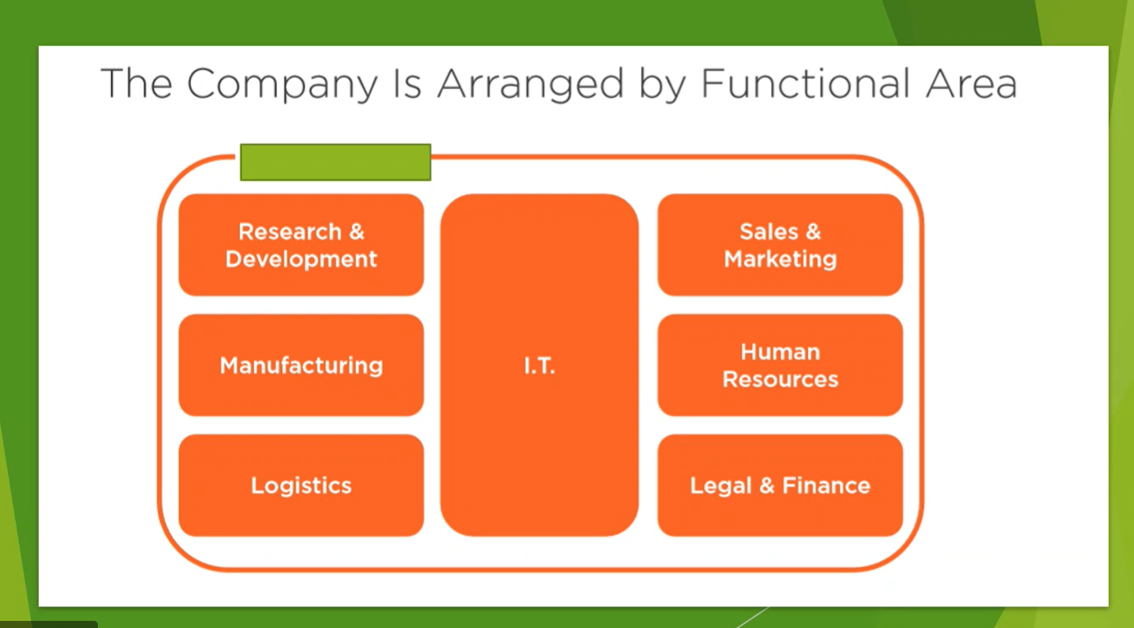

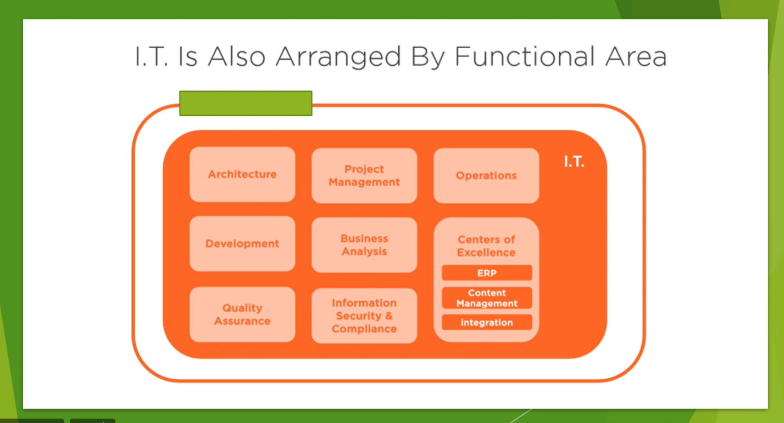

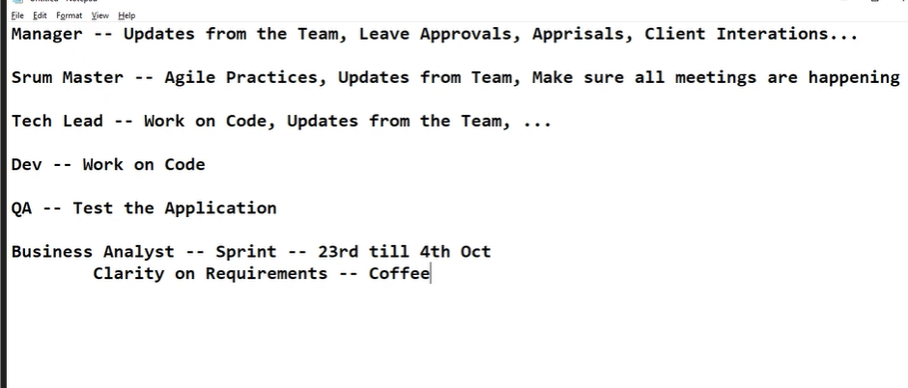

Placing redundant roles

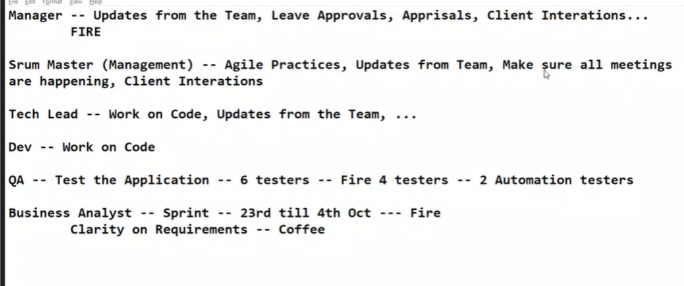

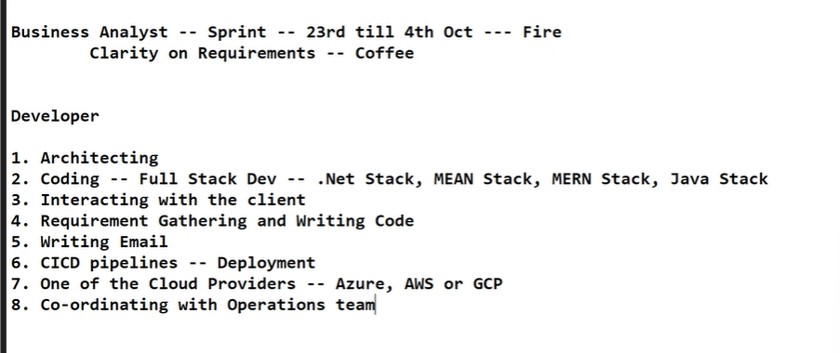

**Creating azure DevOps account**

<https://azure.microsoft.com/en-in/products/devops>

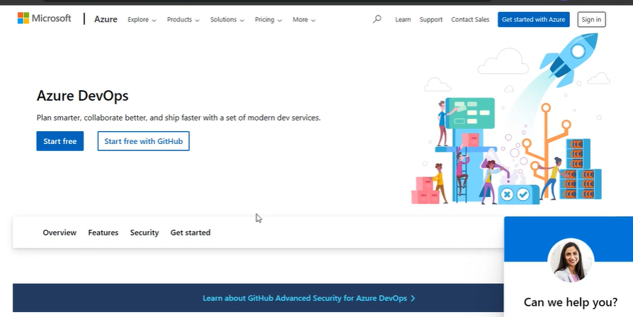

Start free -> login with your outlook account

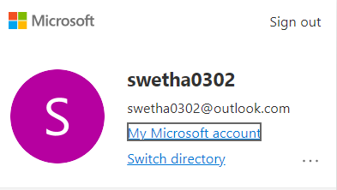

Create project

Select agile in advanced section and create

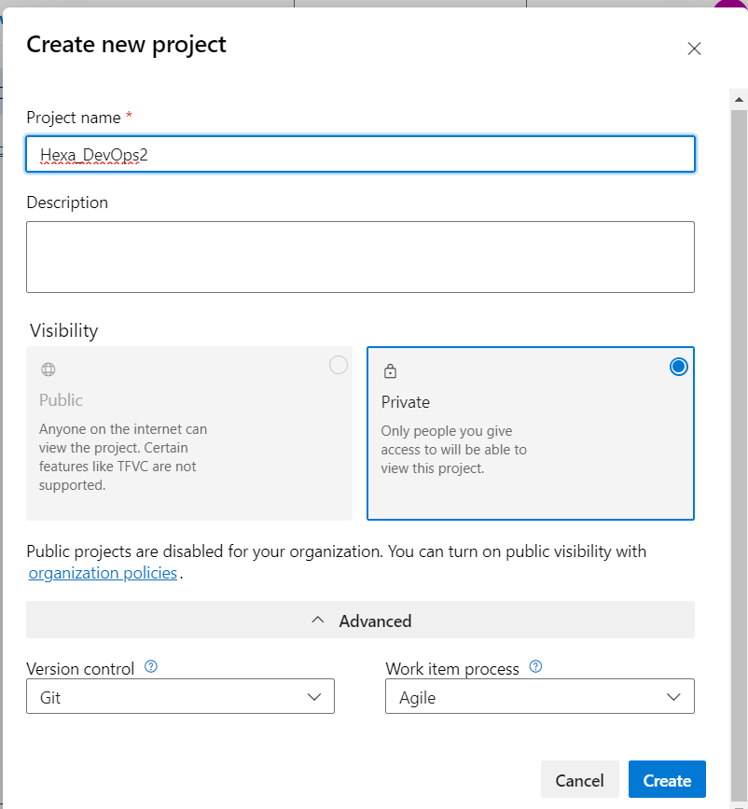

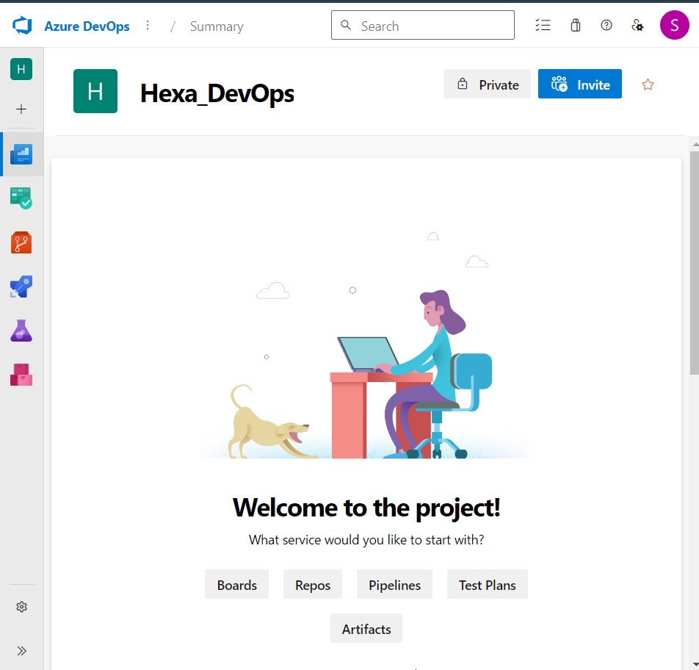

If u want to delete any project:

azure devops 🡪organizational settings 🡪project 🡪select and delete

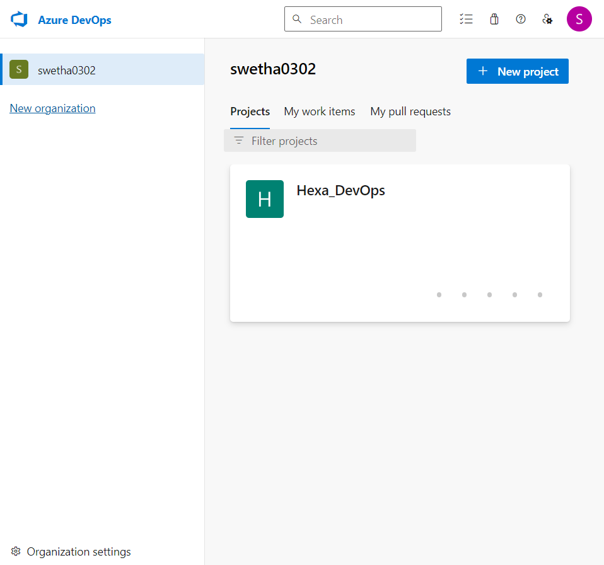

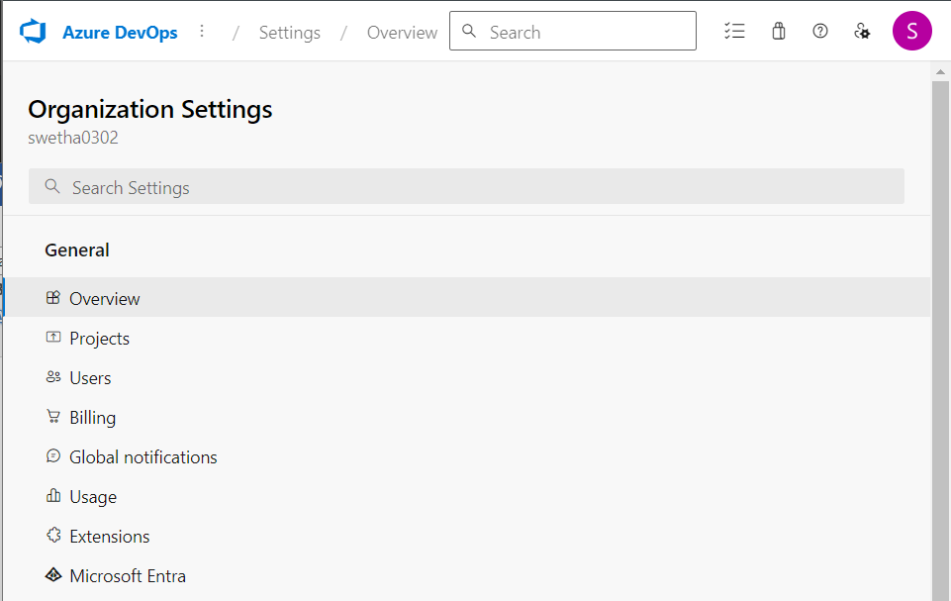

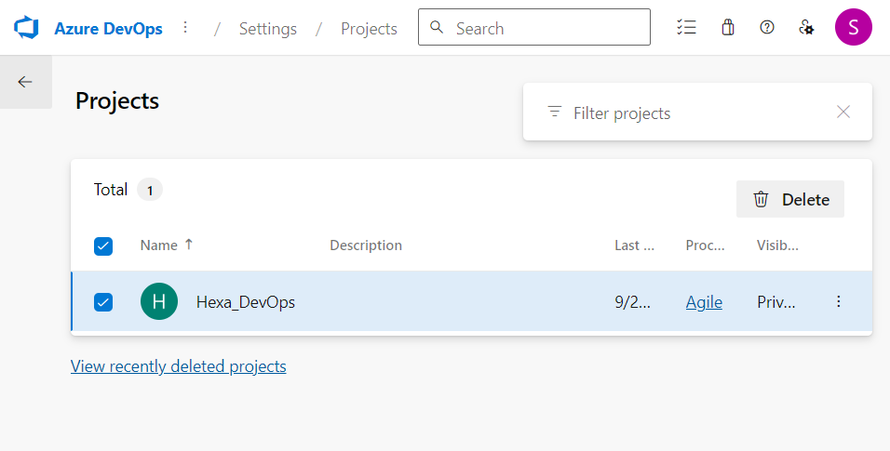

Eg : Customer support page on amazon

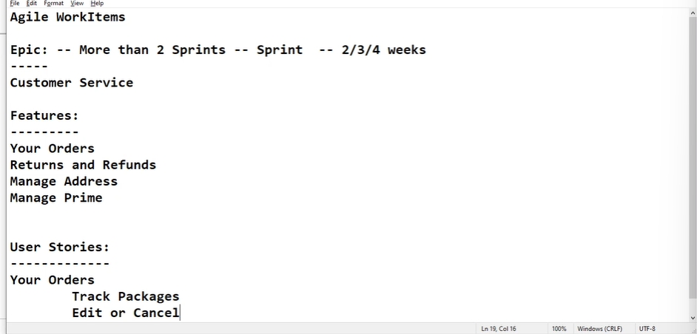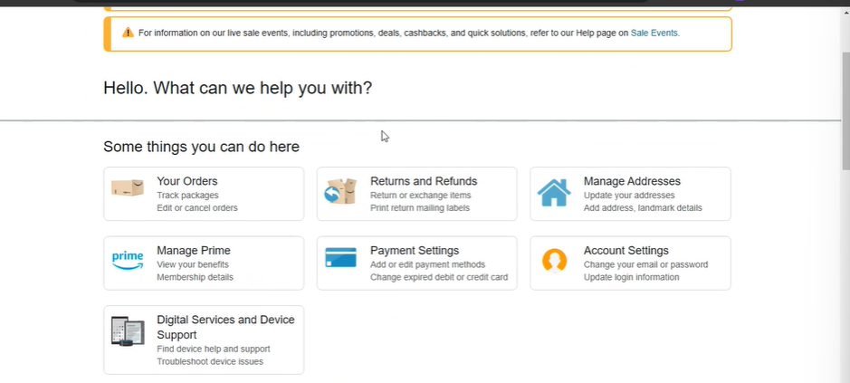

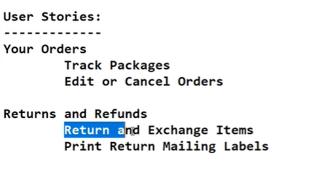

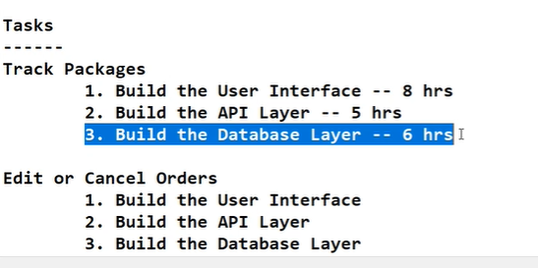

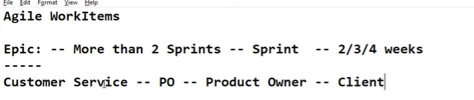

Inside azure devops

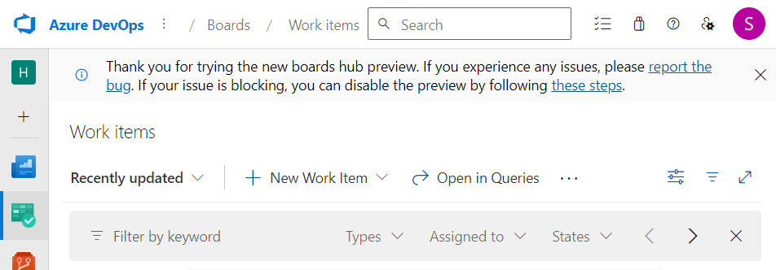

Boards -> new work item -> epic

Name the epic 🡪 give description 🡪 save

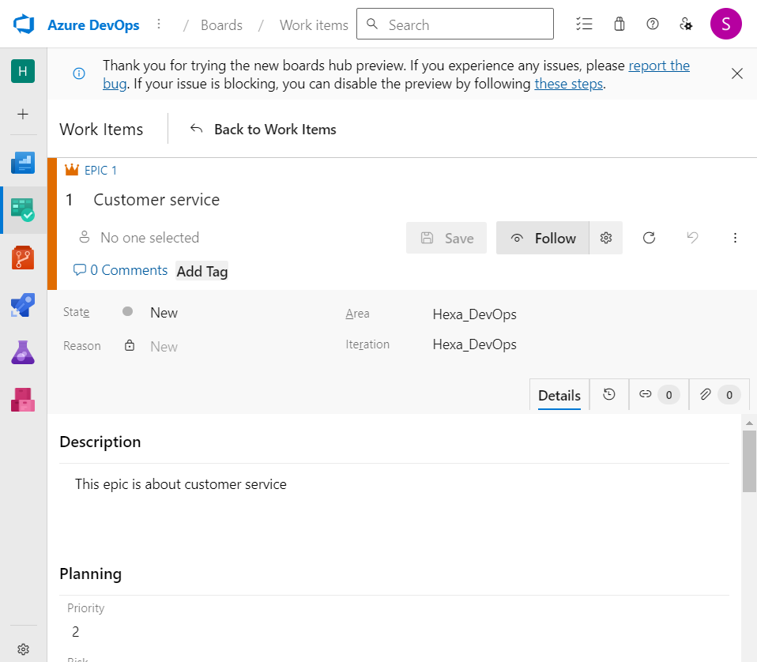

Again work items 🡪features

Create features enter

1.title

2.description

3.priority

4.risk

5.start/end date and time

6.Under deployment 🡪add link 🡪connect all the features to epic(customer service)

7.save

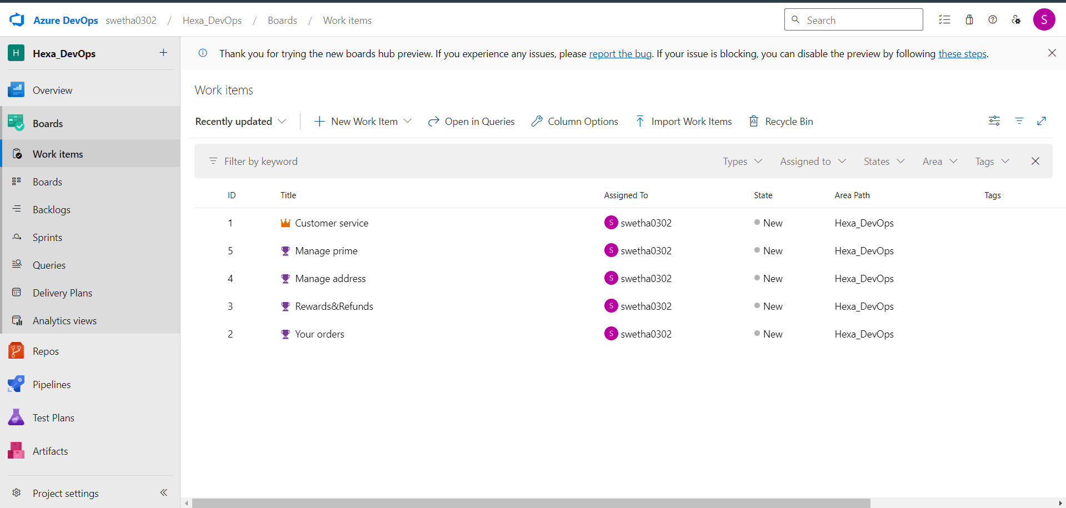

Again new work item 🡪 user story

1.title

2.description

3.acceptance criteria

4.story points

5.priority

6.risk

7.add link(feature link)

8.save

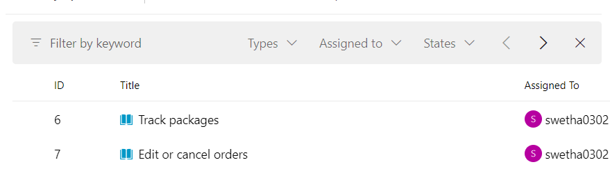

Enter into boards

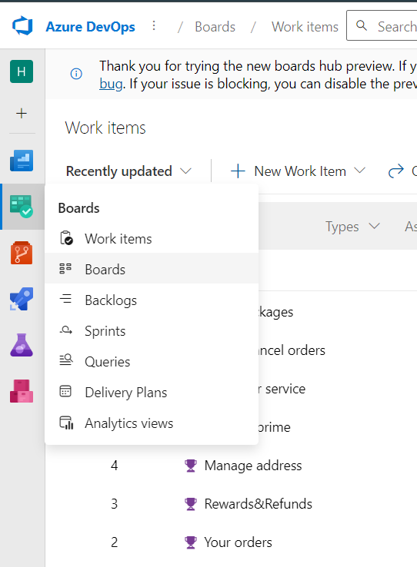

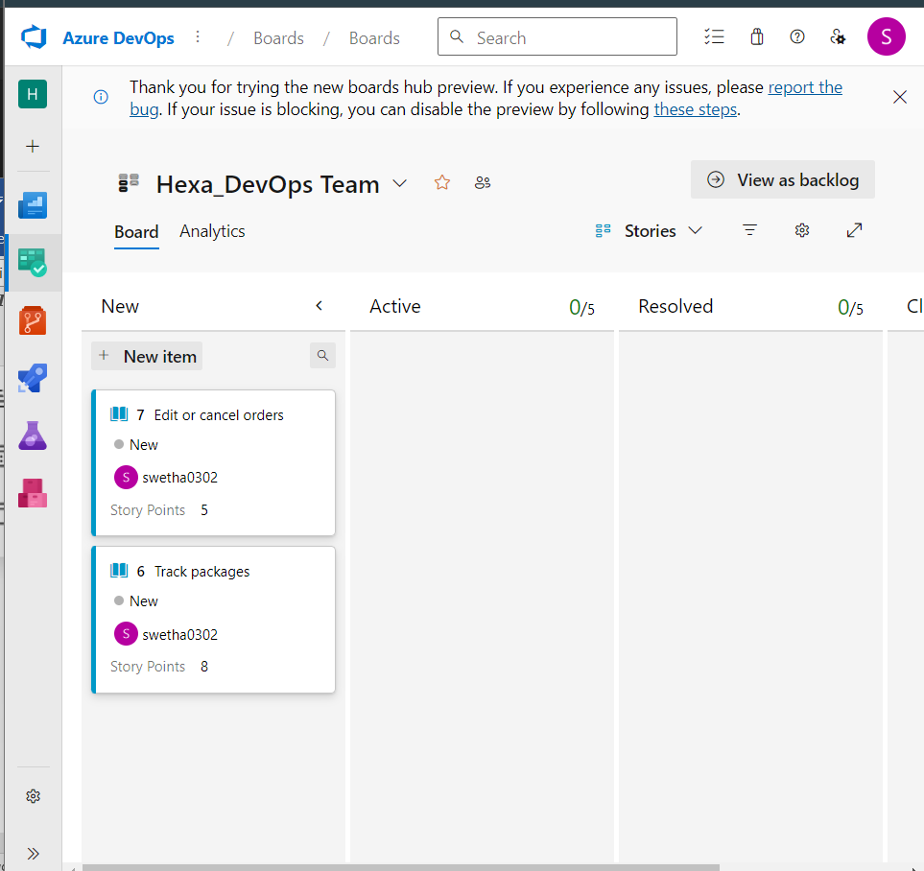

Now manager will monitor the activity of the tasks

Likewise create epic, features, user story

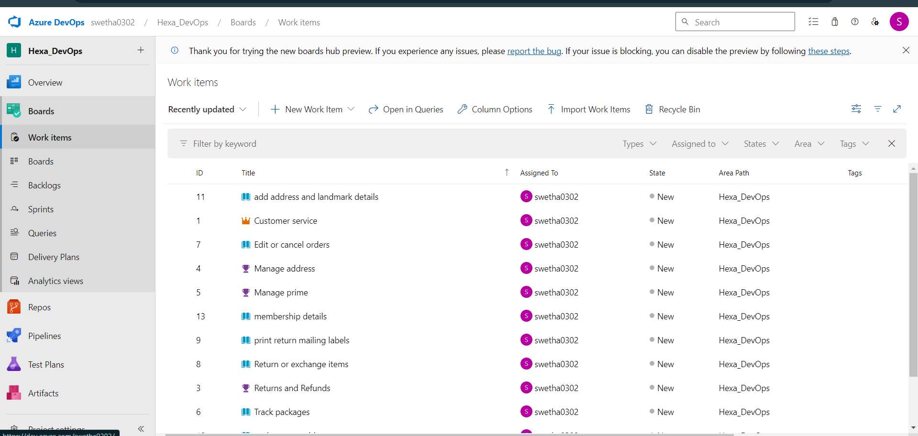

Create tasks under new work items and link user story

Title

Description

Priority

Activity

Original estimate

Remaining

link

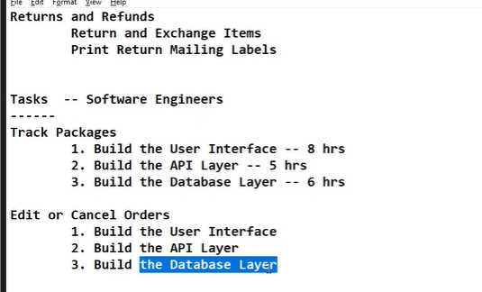

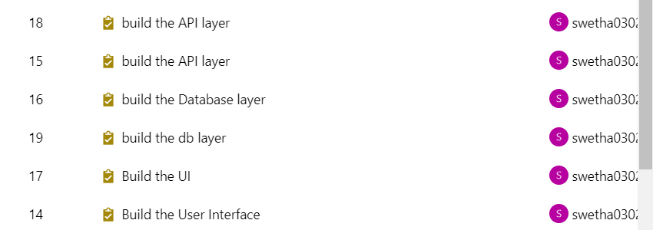

Day 2



Break it down as task,epic,features etc..

EPIC -- Payment Method

Feature 1 : Checkout with amazon pay

- User Story

- Use your Amazon Account

Tasks:

Build a UI

Build an API

Build a database layer to store the transaction information

Feature 2 : Checkout with Paypal

- User Story

- Using PayPal

Tasks:

Build UI

Build API

Build a database layer to store data

Feature 3: Online Credit/Debit Card

- User Story

- Using PayPal Credit

Tasks:

Build UI

Build API

Build a database to store card details

Feature 4: Cash on Delivery

- User Story

- Create checkout

Tasks:

Build UI

Build API

Build a database to store the user information

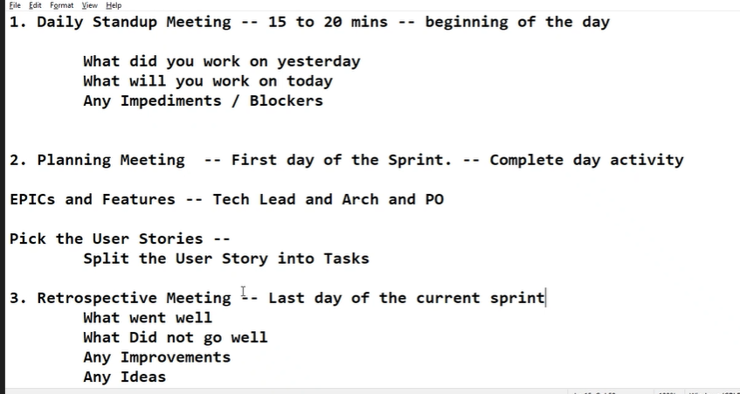

Repos:

Install git for your windows before starting this,

1.Create a empty folder in file manager

2.Open that folder in commond prompt

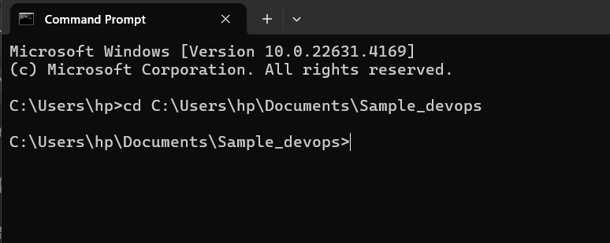

Copy the url in azure devops (repos)

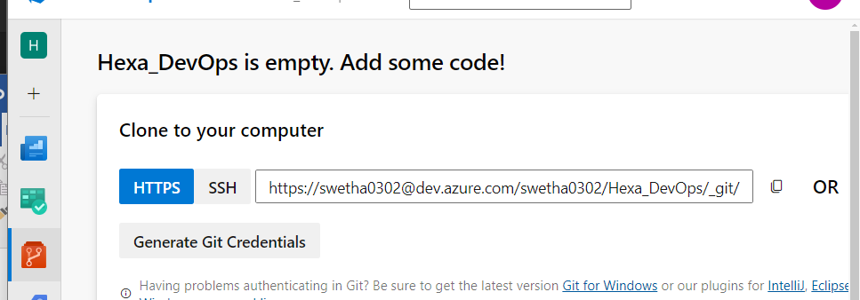

Paste it with git clone (link)

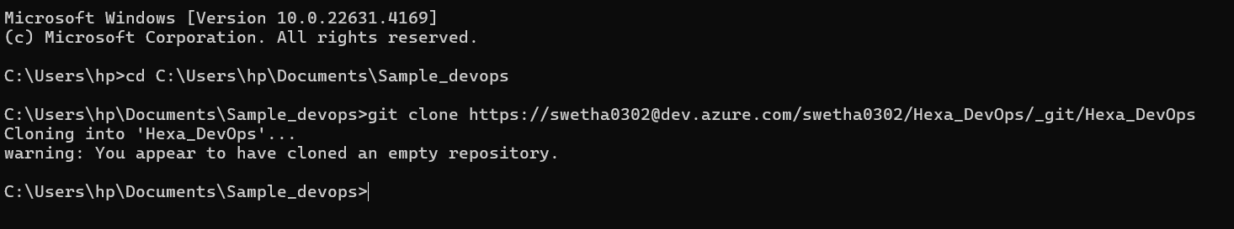

Once it is done open it in vs code by using comment

“code .”

and create 2 sample file

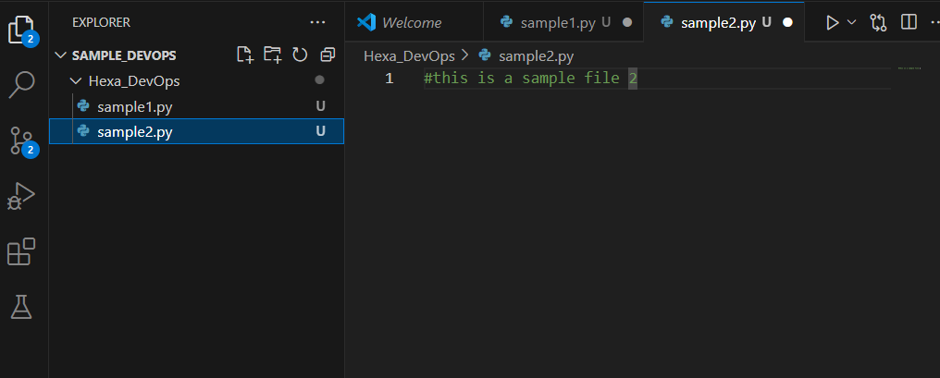

Again open commond prompt

Use this commonds:

git config --global user.name "Swetha"  
  
git config --global user.email swetha@example.com

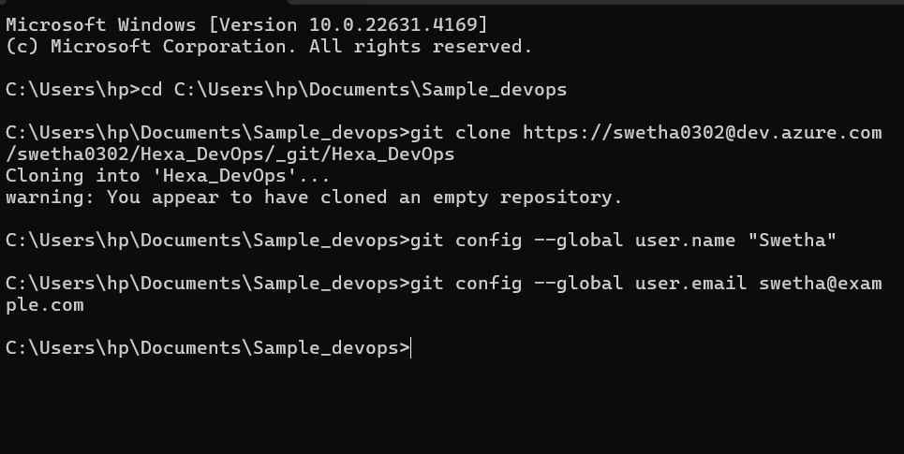

Enter this in commond prompt

Now close the vs code and open it again

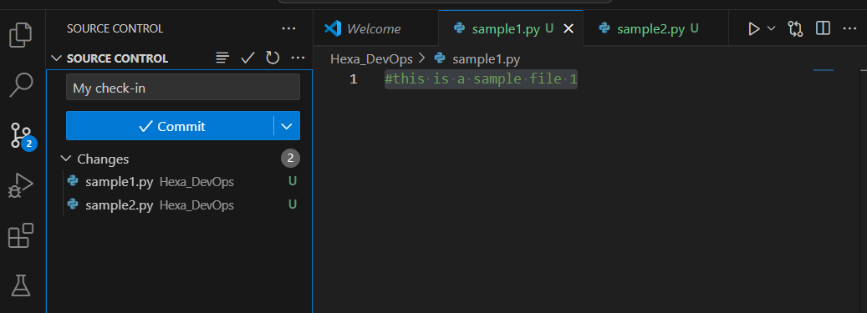

Under Commit dropdown click commit and push

Once done refresh the azure devops portal

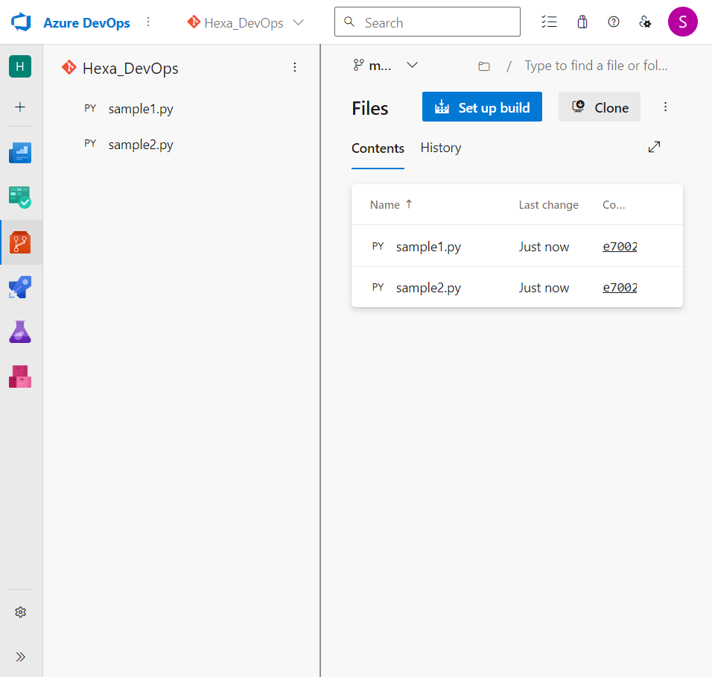

U will get the files in azure portal

It is similar to github where u can store your files

CI/CD – continuous integration and continuous delivery

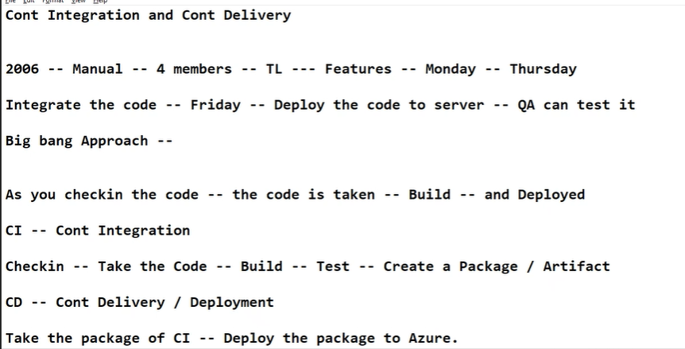

Pipelines:

<https://learn.microsoft.com/en-us/azure/devops/pipelines/get-started/what-is-azure-pipelines?view=azure-devops>

<https://www.azuredevopslabs.com/labs/azuredevops/yaml/>

<https://azuredevopslabs.com/>